**Lab Report-06**

**Title:** HTML and GitHub

*Course title: Web Design and Programming Lab-I*

*Course code: CSE-312*

*3rd Year 1st Semester Examination 2023*

**Date of Submission**: 03/09/2024



**Submitted to-**

**Md Rafsan Jani**

*Assistant Professor*

*Department of Computer Science and Engineering Savar, Dhaka-1342*

|  |  |  |  |
| --- | --- | --- | --- |
| **Sl No.** | **Class Roll** | **Exam Roll** | **Name** |
| 01 | 359 | 210879 | Redwana Jahan |

Department of Computer Science and Engineering

Jahangirnagar University

Savar, Dhaka, Bangladesh

|  |
| --- |
| **Problem No. 01** |

**Screenshot:**

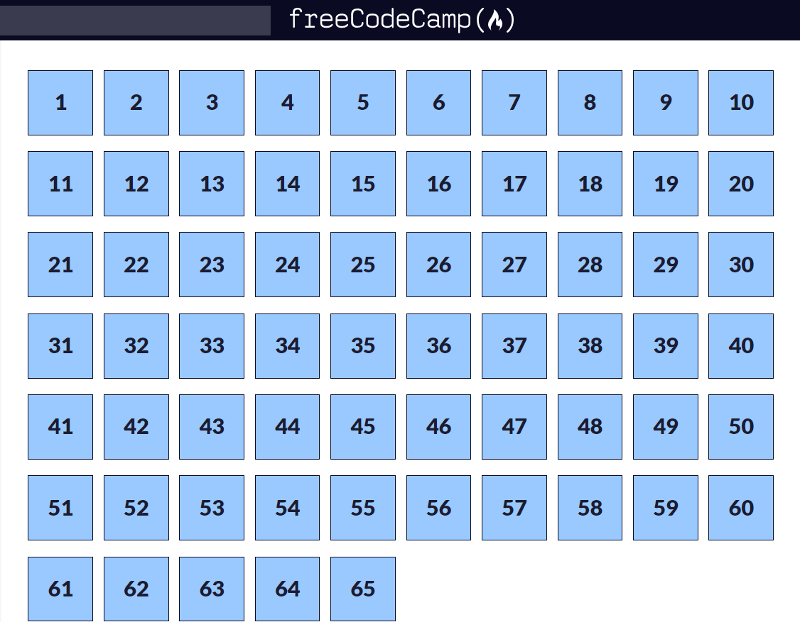

**HTML code:**

<!DOCTYPE html>

<html lang="en">

  <head>

    <meta charset="UTF-8">

    <title>Registration Form</title>

    <link rel="stylesheet" href="styles.css" />

  </head>

  <body>

    <h1>Registration Form</h1>

    <p>Please fill out this form with the required information</p>

    <form method="post" action='https://register-demo.freecodecamp.org'>

      <fieldset>

        <label for="first-name">Enter Your First Name: <input id="first-name" name="first-name" type="text" required /></label>

        <label for="last-name">Enter Your Last Name: <input id="last-name" name="last-name" type="text" required /></label>

        <label for="email">Enter Your Email: <input id="email" name="email" type="email" required /></label>

        <label for="new-password">Create a New Password: <input id="new-password" name="new-password" type="password" pattern="[a-z0-5]{8,}" required /></label>

      </fieldset>

      <fieldset>

        <legend>Account type (required)</legend>

        <label for="personal-account"><input id="personal-account" type="radio" name="account-type" class="inline" checked /> Personal</label>

        <label for="business-account"><input id="business-account" type="radio" name="account-type" class="inline" /> Business</label>

      </fieldset>

      <fieldset>

        <label for="profile-picture">Upload a profile picture: <input id="profile-picture" type="file" name="file" /></label>

        <label for="age">Input your age (years): <input id="age" type="number" name="age" min="13" max="120" /></label>

        <label for="referrer">How did you hear about us?

          <select id="referrer" name="referrer">

            <option value="">(select one)</option>

            <option value="1">freeCodeCamp News</option>

            <option value="2">freeCodeCamp YouTube Channel</option>

            <option value="3">freeCodeCamp Forum</option>

            <option value="4">Other</option>

          </select>

        </label>

        <label for="bio">Provide a bio:

          <textarea id="bio" name="bio" rows="3" cols="30" placeholder="I like coding on the beach..."></textarea>

        </label>

      </fieldset>

      <label for="terms-and-conditions">

        <input class="inline" id="terms-and-conditions" type="checkbox" required name="terms-and-conditions" /> I accept the <a href="https://www.freecodecamp.org/news/terms-of-service/">terms and conditions</a>

      </label>

      <input type="submit" value="Submit" />

    </form>

  </body>

</html>

**CSS code:**

body {

  width: 100%;

  height: 100vh;

  margin: 0;

  background-color: #1b1b32;

  color: #f5f6f7;

  font-family: Tahoma;

  font-size: 16px;

}

h1, p {

  margin: 1em auto;

  text-align: center;

}

form {

  width: 60vw;

  max-width: 500px;

  min-width: 300px;

  margin: 0 auto;

  padding-bottom: 2em;

}

fieldset {

  border: none;

  padding: 2rem 0;

  border-bottom: 3px solid #3b3b4f;

}

fieldset:last-of-type {

  border-bottom: none;

}

label {

  display: block;

  margin: 0.5rem 0;

}

input,

textarea,

select {

  margin: 10px 0 0 0;

  width: 100%;

  min-height: 2em;

}

input, textarea {

  background-color: #0a0a23;

  border: 1px solid #0a0a23;

  color: #ffffff;

}

.inline {

  width: unset;

  margin: 0 0.5em 0 0;

  vertical-align: middle;

}

input[type="submit"] {

  display: block;

  width: 60%;

  margin: 1em auto;

  height: 2em;

  font-size: 1.1rem;

  background-color: #3b3b4f;

  border-color: white;

  min-width: 300px;

}

input[type="file"] {

  padding: 1px 2px;

}

.inline{

  display: inline;

}

a{

  color: #dfdfe2;

}

|  |
| --- |
| **Problem No. 02** |

**Screenshot:**

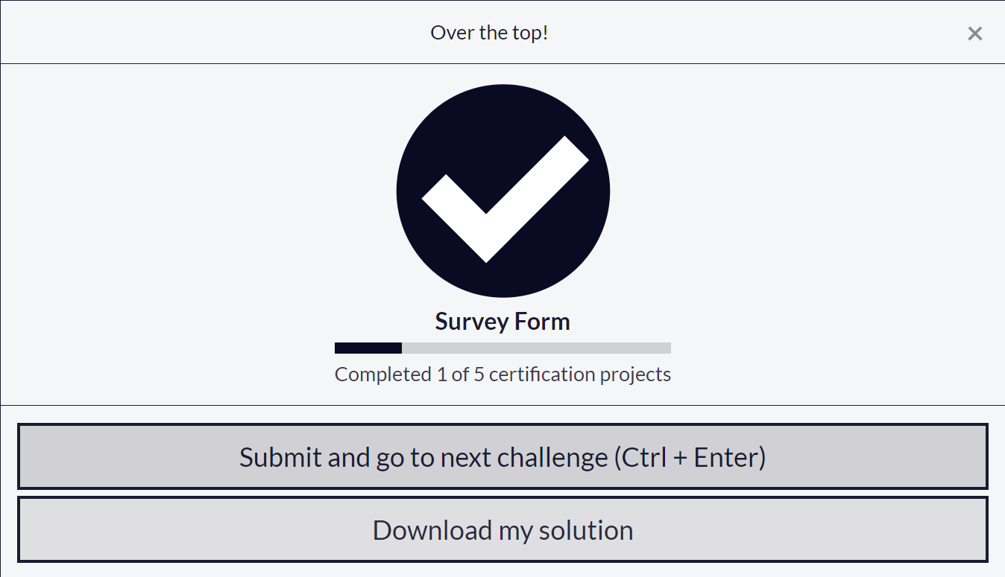

**HTML Code:**

<!DOCTYPE html>

<html lang="en">

<head>

  <meta charset="utf-8">

  <link rel="stylesheet" href="styles.css" />

  <title>Survey Form</title>

</head>

<body>

  <h1 id="title">Survey Form</h1>

  <p id="description">Please fill out the following survey</p>

  <form id="survey-form">

    <label id="name-label" for="name">Name:</label>

    <input type="text" id="name" name="name" placeholder="Enter your name" required>

    <label id="email-label" for="email">Email:</label>

    <input type="email" id="email" name="email" placeholder="Enter your email" required>

    <label id="number-label" for="number">Age:</label>

    <input type="number" id="number" name="age" min="1" max="120" placeholder="Enter your age" required>

    <label for="dropdown">What is your current role?</label>

    <select id="dropdown" name="role" required>

      <option disabled selected value>Select your role</option>

      <option value="student">Student</option>

      <option value="professional">Professional</option>

    </select>

    <label>Do you like this survey?</label>

    <input type="radio" id="yes" name="like" value="yes" required>

    <label for="yes">Yes</label>

    <input type="radio" id="no" name="like" value="no">

    <label for="no">No</label>

    <label>What are your favorite features of this form? (Select all that apply)</label>

    <input type="checkbox" id="design" name="feature" value="design">

    <label for="design">Design</label>

    <input type="checkbox" id="ease" name="feature" value="ease-of-use">

    <label for="ease">Ease of use</label>

    <input type="checkbox" id="speed" name="feature" value="speed">

    <label for="speed">Speed</label>

    <label for="comments">Additional Comments:</label>

    <textarea id="comments" name="comments" rows="5" placeholder="Enter your comments here"></textarea>

    <button type="submit" id="submit">Submit</button>

  </form>

</body>

</html>

**CSS Code:**

body{

      font-family: Arial, sans-serif;

      background-color: #f4f4f9;

      margin: 0;

      padding: 20px;

    }

    survey-form{

      background: white;

      padding: 20px;

      max-width: 600px;

      margin: 0 auto;

      box-shadow: 0 2px 10px rgba(0, 0, 0, 0.1);

    }

    h1,p{

      text-align: center;

    }

    label{

      display: block;

      margin-bottom: 10px;

      font-weight: bold;

    }

    input,select,textarea{

      width: 100%;

      padding: 10px;

      margin-bottom: 20px;

      border: 1px solid #ddd;

      border-radius: 5px;

    }

    input[type="radio"], input[type="checkbox"]{

      width: auto;

    }

    button{

      padding: 10px 20px;

      background-color: #28a745;

      border: none;

      color: white;

      cursor: pointer;

      border-radius: 5px;

      font-size: 16px;

    }

    button:hover{

      background-color: #218838;

    }

|  |
| --- |
| **Problem No. 03** |

**Screenshot:**

